Routledge Encyclopaedia of Modernism Entry

Dorothy Price

Moholy, Lucia (1894-1989)
Lucia Moholy (neé Schulz) was born to Jewish parents in Prague. In 1912 she worked as an English teacher and translator whilst also studying Art History and Philosophy at the University of Prague. In 1915 she left Prague for Germany where she worked as an editor and a lecturer in Wiesbaden and Leipzig. In 1920 she moved to Berlin where she met her future husband, Hungarian artist László Moholy-Nagy whom she married in 1921. In 1923 László Moholy-Nagy was appointed to the Bauhaus by Walter Gropius and the couple moved from Berlin to Weimar. It was during their Bauhaus years from 1923 to 1928 that the Moholy-Nagys established ‘new vision’ photography as one of the most innovative and experimental areas of Bauhaus practice. In 1929 they participated in the famous Film und Foto exhibition in Stuttgart before their divorce in the same year. With the rise of National Socialism in 1933, Lucia was forced to leave Berlin, emigrating first to Prague, then Paris and finally arriving in London in 1934. She was awarded British citizenship in 1947 and died in Switzerland in 1989.

Lucia Moholy’s modernism was consolidated at the Bauhaus in partnership with her husband. Although photography was never a formal workshop, it attracted an enthusiastic following under the couple’s guidance. They became advocates of experimental photographic techniques, which they taught to a subsequent generation of ‘new photographers.’ Unusual camera angles, sophisticated darkroom techniques, experimental photograms playing with the possibilities of light, multiple exposures, ‘combi-phots’ and detailed close-ups that were tantalisingly fresh, constituted the ‘new vision’ in which photography became the expressive vehicle of the future. Smaller cameras and faster exposures provided increased dexterity, enabling them to keep time with the energetic pace of modern life. Unencumbered by the structured expectations of a formal course, photography was practiced as the best sort of experimental play. It particularly attracted female students frustrated by the lack of opportunities elsewhere. One of Lucia Moholy’s enduring legacies from this period is undoubtedly her series of iconic architectural photographs of Bauhaus buildings, specifically Dresden and Berlin and her meticulous documentary photographs of objects and furniture without which knowledge of the significance of Bauhaus design would have been lost after the Second World war. During her enforced exile from Germany she stored her glass plate negative archive with the Gropius’s who, unknown to her, shipped it to the USA with their own belongings. In the years that followed she believed that her five or six hundred negatives had been lost. She therefore had no evidence of her seminal Bauhaus years from which she could build a new practice in England. Penniless and with no belongings she was forced to begin anew, establishing herself as a London society portrait photographer. During this period she also published A Hundred Years of Photography (1939). In 1957, after three years of legal negotiations, she retrieved some of her negatives from the Gropius’s. In 1959 she moved to Switzerland, settling in Zollikon, just outside Zurich where she continued working as a freelance art critic and photographer.
Further Reading
Moholy, Lucia A Hundred Years of Photography London: Penguin 1939
Sachsse, Rolf Lucia Moholy Düsseldorf: Edition Marzona, 1985

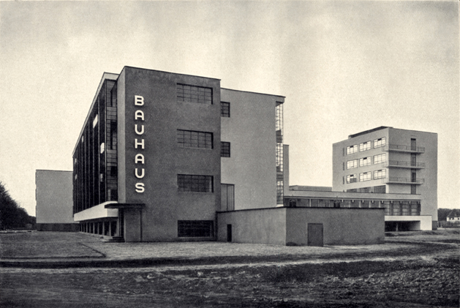

Image: Lucia Moholy Bauhaus Dessau (Workshop Buildings from the Southwest), 1925-26
(available: http://www.thehistoryvault.co.uk/wp-content/uploads/2014/01/Bauhaus0101.jpg)

